1. Differentiate between variables and constants in PHP
Few difference between variables and constants in PHP are given below:
Variables | Constants
The value of a variable can be changed during the execution. | The constant value can’t be changed during script execution.
Variables require compulsory usage of the $ sign at the start. | No dollar sign ($) is required before using a constant.
It is possible to define a variable by simple assignment. | Constants can’t be defined by simple assignments. They are defined using the define() function.
The default scope is the current access scope. | Constants can be accessed throughout without any scoping rules.
2. What is a session in PHP?
A session in PHP is a way to store information to be used across multiple pages of an entire website. The information is not stored on the user’s computer, unlike cookies. In a temporary directory on the server, a file will be created by the session where registered session variables and their values are stored. This information will be available to all pages on the site during that visit.
When you work with an application, you open it, do some modifications, and then you close it. This is much like a Session. The computer knows who you are. It knows when the application is started and ended by you.
But on the internet, the webserver does not know who you are or what you do, because the HTTP address doesn’t maintain a state. This problem is solved using session variables by storing user information to be used across multiple pages (e.g. username, favorite color, etc).
By default, session variables will last until the user closes the browser.
So Session variables hold single user information and are available to all pages in one application.
4. Explain the difference between $message and $$message.
The main difference between the $message and $$message is given below:
$message | $$message
$message is a regular variable. | $$message is a reference variable.
It has a fixed name and stores a fixed value. | It stores data about the variable.
Data stored in $message is fixed. | The value of the $$message can change dynamically as the value of the variable changes.

5. Is PHP a case-sensitive language?
PHP can be considered as a partial case-sensitive language. The variable names are completely case-sensitive but function names are not. Also, user-defined functions are not case-sensitive but the rest of the language is case-sensitive.
For example, user-defined functions in PHP can be defined in lowercase but later referred to in uppercase, and it would still function normally.
6. What are the different types of variables present in PHP?
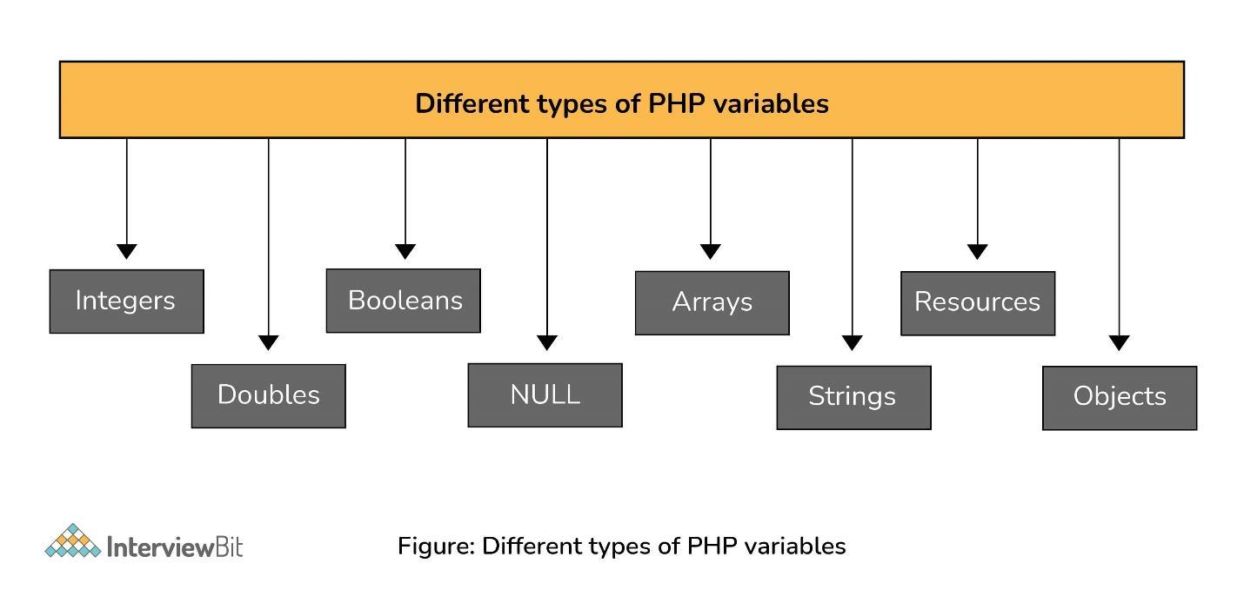Types of PHP Variables
There are 8 primary data types in PHP which are used to construct the variables. They are:
- Integers: Integers are whole numbers without a floating-point. Ex: 1253.
- Doubles: Doubles are floating-point numbers. Ex: 7.876
- Booleans: It represents two logical states- true or false.
- NULL: NULL is a special type that only has one value, NULL. When no value is assigned to a variable, it can be assigned with NULL.
- Arrays: Array is a named and ordered collection of similar type of data. Ex: $colors = array("red", "yellow", "blue");
- Strings: Strings are a sequence of characters. Ex: “Hello InterviewBit!”
- Resources: Resources are special variables that consist of references to resources external to PHP(such as database connections).
- Objects: An instance of classes containing data and functions. Ex: $mango = new Fruit();
7. What are the rules for naming a PHP variable?
The following two rules are needed to be followed while naming a PHP variable:
- A variable must start with a dollar symbol, followed by the variable name. For example: $price=100; where price is a variable name.
- Variable names must begin with a letter or underscore.
- A variable name can consist of letters, numbers, or underscores. But you cannot use characters like + , – , % , & etc.
- A PHP variable name cannot contain spaces.
- PHP variables are case-sensitive. So $NAME and $name both are treated as different variables.
8. What are the different types of Array in PHP?
There are 3 main types of arrays that are used in PHP:
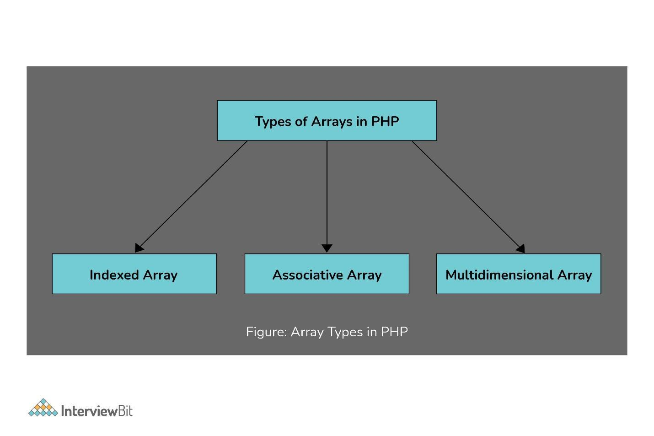Types of Arrays in PHP
Indexed Array
An array with a numeric key is known as the indexed array. Values are stored and accessed in linear order.
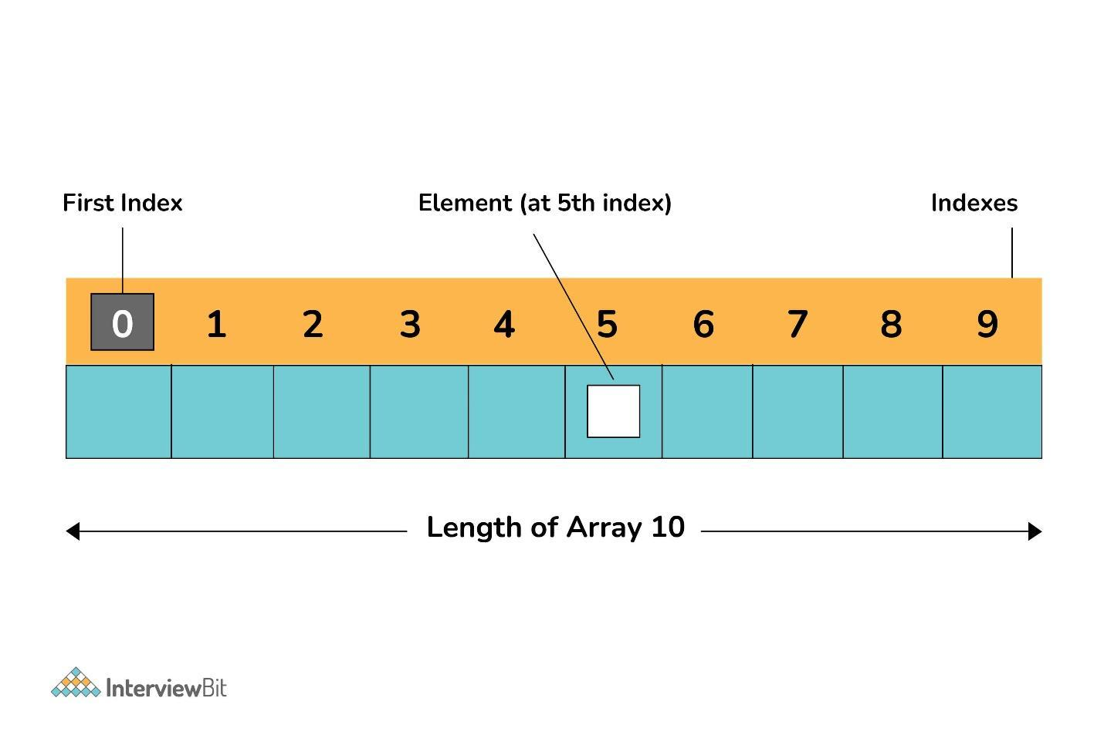Indexed Array
Associative Array
An array with strings for indexing elements is known as the associative array. Element values are stored in association with key values rather than in strict linear index order.
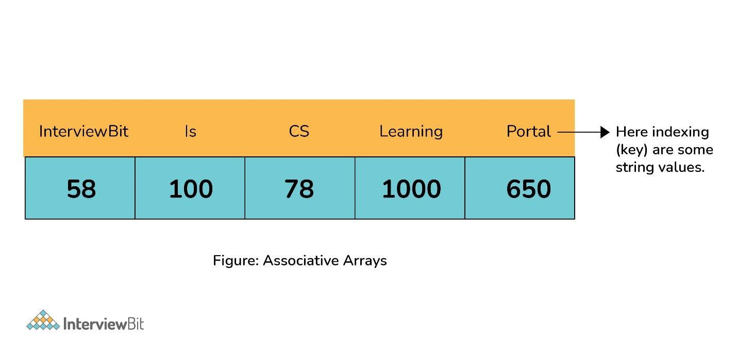Associative Array
Multidimensional Array
An array containing one or more arrays within itself is known as a multidimensional array. The values are accessed using multiple indices.
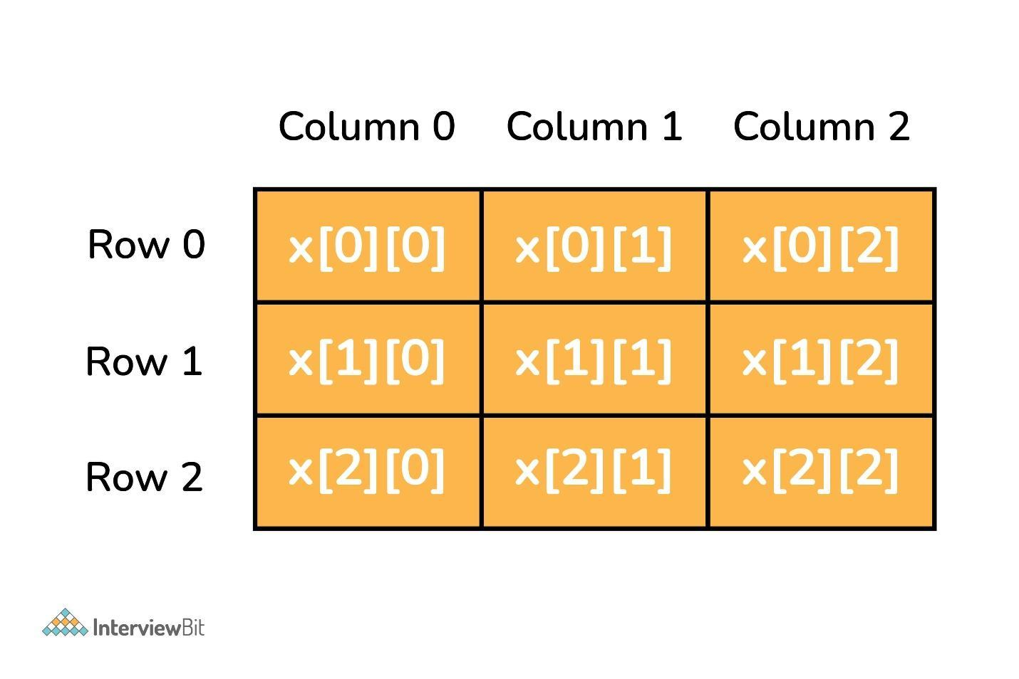Multidimensional Array
9. Explain the main types of errors.
The 3 main types of errors in PHP are:
- Notices: Notices are non-critical errors that can occur during the execution of the script. These are not visible to users. Example: Accessing an undefined variable.
- Warnings: These are more critical than notices. Warnings don’t interrupt the script execution. By default, these are visible to the user. Example: include() a file that doesn’t exist.
- Fatal: This is the most critical error type which, when occurs, immediately terminates the execution of the script. Example: Accessing a property of a non-existent object or require() a non-existent file.

10. What is the difference between the include() and require() functions?
include() function
This function is used to copy all the contents of a file called within the function, text wise into a file from which it is called.
When the file is included cannot be found, it will only produce a warning (E_WARNING) and the script will continue the execution.
require() function:
The require() function performs same as the include() function. It also takes the file that is required and copies the whole code into the file from where the require() function is called.
When the file is included cannot be found, it will produce a fatal error (E_COMPILE_ERROR) and terminates the script.

11. What are cookies? How to create cookies in PHP?
A cookie is a small record that the server installs on the client’s computer. They store data about a user on the browser. It is used to identify a user and is embedded on the user’s computer when they request a particular page. Each time a similar PC asks for a page with a program, it will send the cookie as well.
After verifying the user’s identity in encrypted form, cookies maintain the session id generated at the back end. It must reside in the browser of the machine. You can store only string values not object because you cannot access any object across the website or web apps.
By default, cookies are URL particular. For example, Gmail cookies are not supported by Yahoo and vice versa. Cookies are temporary and transitory by default. Per site 20 cookies can be created in a single website or web app. 50 bytes is the initial size of the cookie and 4096 bytes is the maximum size of the cookie.
In PHP, we can create cookies using the setcookie() function:
setcookie(name, value, expire, path, domain, secure, httponly);
Here name is mandatory and the remaining parameters are optional.

12. What is the use of session_start() and session_destroy() functions in PHP?
The session_start() function is used to start a new session. Also, it can resume an existing session if it is stopped. In this particular case, the return will be the current session if resumed.
Syntax:
session_start();
The session_destroy() function is used to destroy all of the session variables as given below:
<?php
session_start();
session_destroy();
?>

13. What are the different ways of handling the result set of MySQL in PHP?
There are 4 ways of handling the result set of MySQL in PHP. They are:
- mysqli_fetch_array(): Returns the current row of the result set as an associative array, a numeric array, or both.
- mysqli_fetch_assoc(): Returns the current row of the result set as an associative array.
- mysqli_fetch_object(): Returns the current row of a result set, as an object.
- mysqli_fetch_row(): Returns result row as an enumerated array.
14. How to create API in PHP?
API stands for Application Programming Interface. It defines the functions and variables. Communication between the database via PHP extensions is handled by API.
Now, REST API is the web architecture that uses HTTP protocol for exchanging data between two functions that means your application or system. Now, let us have a look at how to create REST API in PHP by considering the example of accessing data from a database using PHP script.
Step 1 - Create a database: To create a database run the query given below:
CREATE DATABASE phptest;
Step 2 - Create a table: After creating a database, you have to create a table with dummy data. To create a table run the query given below:
CREATE TABLE IF NOT EXISTS `transactions`
(
`id` int(20) NOT NULL AUTO_INCREMENT,
`order_id` int(50) NOT NULL,
`amount` decimal(9,2) NOT NULL,
`response_code` int(10) NOT NULL,
`response_desc` varchar(50) NOT NULL,
PRIMARY KEY (`id`),
UNIQUE KEY `order_id` (`order_id`)
) ENGINE=InnoDB DEFAULT CHARSET=latin1 ;
Step 3 - Create a Database Connection: Create a db.php file and paste the below-given database connection in it. Make sure to update these credentials with your database credentials.
<?php
// Enter your Host, username, password, database below.
$con = mysqli_connect("localhost","root","","phptest");
if (mysqli_connect_errno())
{
echo "Failed to connect to MySQL: " . mysqli_connect_error();
die();
}
?>
Step 4 - Create a REST API File: Create an api.php file and copy the following script in it.
<?php
header("Content-Type:application/json");
if (isset($_GET['order_id']) && $_GET['order_id']!="")
{
include('db.php');
$order_id = $_GET['order_id'];
$result = mysqli_query($con,
"SELECT * FROM `transactions` WHERE order_id=$order_id");
if(mysqli_num_rows($result)>0)
{
$row = mysqli_fetch_array($result);
$amount = $row['amount'];
$response_code = $row['response_code'];
$response_desc = $row['response_desc'];
response($order_id, $amount, $response_code, $response_desc);
mysqli_close($con);
}
else
{
response(NULL, NULL, 200,"No Record Found");
}
}
else
{
response(NULL, NULL, 400,"Request is invalid");
}
function response($order_id,$amount,$response_code, $response_desc)
{
$response['order_id'] = $order_id;
$response['amount'] = $amount;
$response['response_code'] = $response_code;
$response['response_desc'] = $response_desc;
$json_response = json_encode($response);
echo $json_response;
}
?>
The above code will accept the GET request and return output in the JSON format.
Now you can get an output as given below:
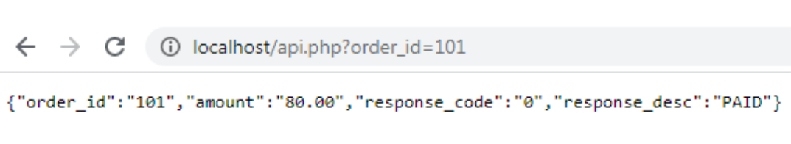

15. Differentiate between GET and POST
The difference between GET and POST are given below:
GET | POST
GET method is used for requesting data from a specified resource. | POST is used for sending the data to the server as a package in a separate communication with the processing script.
Data is sent in the form of URL parameters which are strings of name-value pairs separated by ampersands(&) | Data sent through the POST method will not be seen in the URL
GET method cannot be used for sending binary data like images or word documents | The POST method can be used to send ASCII as well as binary data like images and word documents
This method must not be used if you have any sensitive information like a password to be sent to the server. | Sensitive information can be sent using this method.
It can be used for submitting the form where the user can bookmark the result. | Submissions by form with POST cannot be bookmarked.
You can use this method only for data that is not secure. | Data sent through this method is secure.
GET method is not safer since parameters may be stored in web server logs or browser history. | POST method is safer than GET because the parameters are not stored in web server logs or browser history.

=======OOP PHP=========

Four Principles of OOP
The four pillars of object-oriented programming are:
- Inheritance: child classes inherit data and behaviors from the parent class
- Encapsulation: containing information in an object, exposing only selected information
- Abstraction: only exposing high-level public methods for accessing an object
- Polymorphism: many methods can do the same task
Classes and objects are the two main aspects of object-oriented programming.
Look at the following illustration to see the difference between class and objects:

class
- Fruit

objects
- Apple
- Banana
- Mango

##A class is defined by using the class keyword, followed by the name of the class and a pair of curly braces ({}). All its properties and methods go inside the braces:

Syntax
<?php
class Fruit {
// code goes here...
}
?>
Define Objects
Classes are nothing without objects! We can create multiple objects from a class. Each object has all the properties and methods defined in the class, but they will have different property values.
Objects of a class are created using the new keyword.

PHP - The __construct Function
A constructor allows you to initialize an object's properties upon creation of the object.
If you create a __construct() function, PHP will automatically call this function when you create an object from a class.
Notice that the construct function starts with two underscores (__)!

PHP - The __destruct Function
A destructor is called when the object is destructed or the script is stopped or exited.
If you create a __destruct() function, PHP will automatically call this function at the end of the script.
Notice that the destruct function starts with two underscores (__)!

PHP - Access Modifiers
Properties and methods can have access modifiers which control where they can be accessed.
There are three access modifiers:
- public - the property or method can be accessed from everywhere. This is default
- protected - the property or method can be accessed within the class and by classes derived from that class
- private - the property or method can ONLY be accessed within the class

PHP - What is Inheritance?
Inheritance in OOP = When a class derives from another class.
The child class will inherit all the public and protected properties and methods from the parent class. In addition, it can have its own properties and methods.
An inherited class is defined by using the extends keyword.

PHP - Class Constants
Class constants can be useful if you need to define some constant data within a class.
A class constant is declared inside a class with the const keyword.
A constant cannot be changed once it is declared.
Class constants are case-sensitive. However, it is recommended to name the constants in all uppercase letters.
We can access a constant from outside the class by using the class name followed by the scope resolution operator (::) followed by the constant name, like here
<?php
class Goodbye {
const LEAVING_MESSAGE = "Thank you for visiting W3Schools.com!";
}
echo Goodbye::LEAVING_MESSAGE;
?>
Or, we can access a constant from inside the class by using the self keyword followed by the scope resolution operator (::) followed by the constant name, like here:
Example
<?php
class Goodbye {
const LEAVING_MESSAGE = "Thank you for visiting W3Schools.com!";
public function byebye() {
echo self::LEAVING_MESSAGE;
}
}
$goodbye = new Goodbye();
$goodbye->byebye();
?>

PHP - What are Abstract Classes and Methods?
Abstract classes and methods are when the parent class has a named method, but need its child class(es) to fill out the tasks.
An abstract class is a class that contains at least one abstract method. An abstract method is a method that is declared, but not implemented in the code.

Syntax
<?php
abstract class ParentClass {
abstract public function someMethod1();
abstract public function someMethod2($name, $color);
abstract public function someMethod3() : string;
}
?>

PHP - What are Interfaces?
Interfaces allow you to specify what methods a class should implement.
Interfaces make it easy to use a variety of different classes in the same way. When one or more classes use the same interface, it is referred to as "polymorphism".
Interfaces are declared with the interface keyword:

Syntax
<?php
interface InterfaceName {
public function someMethod1();
public function someMethod2($name, $color);
public function someMethod3() : string;
}
?>

PHP - What are Traits?
PHP only supports single inheritance: a child class can inherit only from one single parent.
So, what if a class needs to inherit multiple behaviors? OOP traits solve this problem.
Traits are used to declare methods that can be used in multiple classes. Traits can have methods and abstract methods that can be used in multiple classes, and the methods can have any access modifier (public, private, or protected).
Traits are declared with the trait keyword:

Syntax
<?php
trait TraitName {
// some code...
}
?>

PHP - Static Methods
Static methods can be called directly - without creating an instance of the class first.
Static methods are declared with the static keyword:

Syntax
<?php
class ClassName {
public static function staticMethod() {
echo "Hello World!";
}
}
?>
To access a static method use the class name, double colon (::), and the method name:

Syntax
ClassName::staticMethod();
Example
<?php
class greeting {
public static function welcome() {
echo "Hello World!";
}
}
// Call static method
greeting::welcome();
?>

PHP - Static Properties
Static properties can be called directly - without creating an instance of a class.
Static properties are declared with the static keyword:

Syntax
<?php
class ClassName {
public static $staticProp = "W3Schools";
}
?>
To access a static property use the class name, double colon (::), and the property name:

Syntax
ClassName::$staticProp;
Let's look at an example:

Example
<?php
class pi {
public static $value = 3.14159;
}
// Get static property
echo pi::$value;
?>

PHP Namespaces
Namespaces are qualifiers that solve two different problems:
- They allow for better organization by grouping classes that work together to perform a task
- They allow the same name to be used for more than one class
For example, you may have a set of classes which describe an HTML table, such as Table, Row and Cell while also having another set of classes to describe furniture, such as Table, Chair and Bed. Namespaces can be used to organize the classes into two different groups while also preventing the two classes Table and Table from being mixed up.

Declaring a Namespace
Namespaces are declared at the beginning of a file using the namespace keyword:

Syntax
Declare a namespace called Html:
<?php
namespace Html;
?>
Note: A namespace declaration must be the first thing in the PHP file. The following code would be invalid:
<?php
echo "Hello World!";
namespace Html;
...
?>

PHP - What is an Iterable?
An iterable is any value which can be looped through with a foreach() loop.
The iterable pseudo-type was introduced in PHP 7.1, and it can be used as a data type for function arguments and function return values.

PHP - Using Iterables
The iterable keyword can be used as a data type of a function argument or as the return type of a function:

Example
Use an iterable function argument:
<?php
function printIterable(iterable $myIterable) {
foreach($myIterable as $item) {
echo $item;
}
}
$arr = ["a", "b", "c"];
printIterable($arr);
?>

Laravel
1. What is Laravel?
Answer
Laravel is a free, open-source PHP web framework, created by Taylor Otwell and intended for the development of web applications following the model–view–controller (MVC) architectural pattern.
2.What are some benefits of Laravel over other Php frameworks?
Answer
- Setup and customization process is easy and fast as compared to others.
- Inbuilt Authentication System
- Supports multiple file systems
- Pre-loaded packages like Laravel Socialite, Laravel cashier, Laravel elixir, Passport, Laravel Scout
- Eloquent ORM (Object Relation Mapping) with PHP active record implementation
- Built in command line tool “Artisan” for creating a code skeleton ,database structure and build their migration
2) Name databases supported by Laravel.
Laravel supports the following databases:
- PostgreSQL
- SQL Server
- SQLite
- MySQL

3) Explain PHP artisan
artisan is a command-line tool of Laravel. It provides commands that help you to build Laravel applications without any hassle.
4) What are common HTTP error codes?
The most common HTTP error codes are:
- Error 404 – Displays when Page is not found.
- Error- 401 – Displays when an error is not authorized

5) What is the use of dd() function?
This function is used to dump contents of a variable to the browser. The full form of dd is Dump and Die.
6) List out common artisan commands used in Laravel.
Laravel supports following artisan commands:
- PHP artisan down;
- PHP artisan up;
- PHP artisan make:controller;
- PHP artisan make:model;
- PHP artisan make:migration;
- PHP artisan make:middleware;
7) Differentiate between delete() and softDeletes().
- delete(): remove all record from the database table.
- softDeletes(): It does not remove the data from the table. It is used to flag any record as deleted.

8) Explain faker in Laravel.
It is a type of module or packages which are used to create fake data. This data can be used for testing purpose.
It is can also be used to generate: 1) Numbers, 2) Addresses, 3) DateTime, 4) Payments, and 5) Lorem text.
9) List basic concepts in Laravel?
Following are basic concepts used in Laravel:
- Routing
- Eloquent ORM
- Middleware
- Security
- Caching
- Blade Templating
10) What is MVC framework?
It is Model, View, and Controller:
- Model: Model defines logic to write Laravel application.
- View: It covers the UI logic of Laravel application.
- Controller: It is work as an interface between Model, and View. It is a way how the user interacts with an application.

11) Define @include.
@include is used to load more than one template view files. It helps you to include view within another view. User can also load multiple files in one view.
12) What is Eloquent?
Eloquent is an ORM used in Laravel. It provides simple active record implementation working with the database. Each database table has its Model, which used to interact with the table.

13) Name some Inbuilt Authentication Controllers of Laravel.
Laravel installation has an inbuilt set of common authentication controllers. These controllers are:
- RegisterController
- LoginController
- ResetPasswordController
- ForgetPasswordController

14) What is the use of DB facade?
DB facade is used to run SQL queries like create, select, update, insert, and delete.
15) What is Ajax in Laravel?
Ajax stands for Asynchronous JavaScript and XML is a web development technique that is used to create asynchronous Web applications. In Laravel, response() and json() functions are used to create asynchronous web applications.

16) What is a session in Laravel?
Session is used to pass user information from one web page to another. Laravel provides various drivers like a cookie, array, file, Memcached, and Redis to handle session data.

17) How to access session data?
Session data be access by creating an instance of the session in HTTP request. Once you get the instance, use get() method with a “Key” as a parameter to get the session details.

18) What is the namespace in Laravel?
A namespace allows a user to group the functions, classes, and constants under a specific name.

19. What is Kept in the vendor directory of Laravel ?

Ans: Any packages that are pulled from composer is kept in vendor directory of Laravel.

20. What are Laravel Contracts ?

Ans: Laravel’s Contracts are nothing but set of interfaces that define the core services provided by the Laravelframework.

21. What does PHP compact function do ?

Ans: compact() laravel
PHP compact function takes each key and tries to find a variable with that same name.If the variable is found, them it builds an associative array.

22. In which directory controllers are located in Laravel ?

Ans: We kept all controllers in App/Http/Controllers directory

23. Define ORM ?

Ans: Object-relational Mapping (ORM) is a programming technique for converting data between incompatible type systems in object-oriented programming languages.

24. How to create a record in Laravel using eloquent ?
Ans: To create a new record in the database using Laravel Eloquent, simply create a new model instance, set attributes on the model, then call the save method: Here is sample Usage.
public function saveProduct(Request $request )
$product = new product;
$product->name = $request->name;
$product->description = $request->name;
$product->save();

25. How to get Logged in user info in Laravel ?
Ans: Auth::User() function is used to get Logged in user info in Laravel.
Usage:-

if(Auth::check()){
$loggedIn_user=Auth::User();
dd($loggedIn_user);
}

VUEJS 3
1. ABOUT VUE JS
Vue JS is a continuous open-source framework for JavaScript used to improve interactive web
communication. It is one of the most widely used frameworks for web development. Vue JS focuses on
the viewing layer. It can be easily applied to major pre-development projects without problems.
Initial release: February 2014
Stable release: 3.0.2 / October 20, 2020
Original author(s): Evan You
Size: 33.30KB
License: MIT License
Written in: JavaScript, TypeScript (Vue 3.0)
2) What is Vue.js?

Vue js is progressive javascript script used to create dynamic user interfaces.Vue js is very easy to learn.In order to work with Vue js you just need to add few dynamic features to a website.You don’t need to install any thing to use Vue js just need add Vue js library in your project.

4) List some features of Vue.js.

Vue js comes with following features
- Templates
- Reactivity
- Components
- Transitions
- Routing

5) Explain Life cycle of Vue Instance.

The Life cycle of each Vue instance goes through a series of initialization steps when it is created.
– for example, it needs to set up data observation, compile the template, and create the necessary data bindings. Along the way, it will also invoke some lifecycle hooks, which give us the opportunity to execute custom logic. For example, the created hook is called after the instance is created:
new Vue({
data: {
a: 1
},
created: function () {
// `this` points to the vm instance
console.log('a is: ' + this.a)
}
})
// => "a is: 1"
There are also other hooks which will be called at different stages of the instance’s lifecycle, for example compiled, ready and destroyed. All lifecycle hooks are called with their this context pointing to the Vue instance invoking it. Some users may have been wondering where the concept of “controllers” lives in the Vue.js world, and the answer is: there are no controllers in Vue.js. Your custom logic for a component would be split among these lifecycle hooks.

Lifecycle Diagram
Below diagram shows complete life cycle of Vue Instance
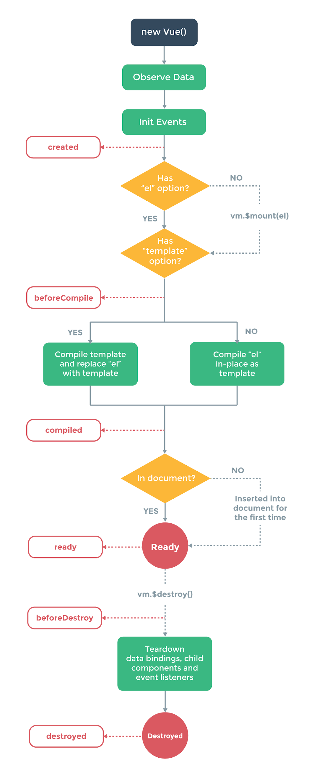

6) How to create an instance of Vue js.

You can create Vue instance with the Vue function:
var vm = new Vue({
// options
})

7) Explain the differences between one-way data flow and two-way data binding?

In one-way data flow the view(UI) part of application does not updates automatically when data Model is change we need to write some custom code to make it updated every time a data model is changed.
In Vue js v-bind is used for one-way data flow or binding.
In two-way data binding the view(UI) part of application automatically updates when data Model is changed.
In Vue.js v-model directive is used for two way data binding.

8) How to create Two-Way Bindings in Vue.js?

v-model directive is used to create Two-Way Bindings in Vue js.In Two-Way Bindings data or model is bind with DOM and Dom is binded back to model.
In below example you can see how Two-Way Bindings is implemented.
<div id="app">
{{message}}
<input v-model="message">
</div>
<script type="text/javascript">
var message = 'Vue.js is rad';
new Vue({ el: '#app', data: { message } });
</script>

9) What are filters in VUE.js?

In Vue js filters are used to transform the output that are going to rendered on browser.
A Vue.js filter is essentially a function that takes a value, processes it, and then returns the processed value. In the markup it is denoted by a single pipe (|) and can be followed by one or more arguments:
<element directive="expression | filterId [args...]"></element>
In Vue 2.0, there are no built-in filters are availables, however you are free to create your own filters.

10) How to create a custom filter in Vue.js?

Vue.filter() method is used to create and register a custom filter in Vue js. Vue.filter() method takes two parameters a filterId that is usnique name to filter that you going to create and a filter function that takes a value as the argument and returns the transformed value.
Vue.filter('reverse', function (value) {
return value.split('').reverse().join('')
})

11) What are Components in Vue.js? How to register a component inside other component

Vue Components are one of most powerful features of Vue js.In Vue components are custom elements that help you extend basic HTML elements to encapsulate reusable code.
Following is the way to register a Vue component inside other component
export default {
el: '#your-element'
components: {
'your-component'
}
}

12) What are Directives in VUE.js, List some of them you used?

The concept of directive in Vue js is drastically simpler than that in Angular. Vue.js directives provides a way to extend HTML with new attributes and tags. Vue.js has a set of built-in directives which offers extended functionality to your applications.You can also write your custom directives in Vue.js .
Below are list of commonly used directives in Vue.js
- v-show
- v-if
- v-model
- v-else
- v-on

13) List type of Directive are available in Vuejs.

In Vue js following types of directives are available
- General Directives
- Literal Directives
- Empty Directives
- Custom Directives

14) What is VUE-resource, how can you install Vue Resource ?

VUE-resource is a plugin for vue.js that provides services for making web requests and handle responses using a XMLHttpRequest or JSONP
You can install it via yarn or NPM.
$ yarn add vue-resource
$ npm install vue-resource

15) How to create Constants in Vue js.

To create constant const keyword is used. In Vue.js we suggest creating a separate file for defining your constants.
Example:

Creating a Constant in Vue js.
export const SITE_URL = 'https://www.onlineinterviewquestions.com';

Importing a Constant in Vue js.
import {SITE_URL} from './path/to/constants.js';

16) What is virtual dom in Vuejs?

Virtual DOM in Vue is a JavaScript object that represents the Document Object Model (DOM). The application updates the Virtual DOM instead of the DOM directly. So, it minimizes the updating cost of the real DOM as it is computationally expensive. Virtual DOM offers the ability to control the timing at which the Virtual DOM is rendered. Virtual DOM will just maintain the state of the data without re-rendering until you choose it. Virtual DOM also offers the ability to optimize the performance of your web applications by minimizing the number of times the DOM has to be updated.

17) Why we need Vue.js mixins?

Mixins in Vue JS are a chunk of defined logic that is stored in a particular way. It can be re-used over and over to add functionality to your Vue instances and components. It is important that we need Vue JS because,
- You can easily adhere to the DRY principle with mixins. It ensures that you do not repeat yourself.
- You get a lot of flexibility with mixins. Mixin contains options for Vue components.
- Mixins are safe and they do not affect changes outside their defined scope.
- Mixins in Vue JS are a great platform for code reusability.

18) What is Vuex?

VueX is a state management pattern and library for the application using Vue JS. it acts as a centralized store for all the different components in your Vue JS application. It has rules to ensure that the state can be only mutated in a predictable fashion. It can be integrated with the official devtool extension of Vue to provide additional features. Vuex mainly helps in dealing with shared state management with the cost of more concepts and boilerplate.

19) What are filters in Vuejs?

Filters in Vue JS helps in applying common text formatting. It is used in two places, mustache interpolations, and v-bind expressions. It mainly filters the data on the DOM level. So you get data that is still intact in the storage but is represented in the custom specified manner. It enhances the presentation of the view layer. The filters are also reusable. You can declare a filter globally and use it on any desirable component. It gives you the power to format your data at the view level.

20) How to create a component in Vue js?

Components in Vue JS are a single, independent unit of an interface. They have their own state, markup, and style.
A Vue component can be defined in four ways.
- The first is new Vue({ /*options */ }).
- The second is Vue.component(‘component-name’, { /* options */ }).
- The third way is by using the local components.
- The fourth is in the .vue files or Single File Components.
The first two ways are the standard ways to use Vue when building an application that is not a SPA (Single Page Application). The Single File Components are uses in the Single Page Application.

21) How to import js file in the Vue component?

There are two ways to import a JavaScript library to the Vue Component.
The first is to import a local JavaScript library. Here, you can import the JavaScript library by using the 'import' keyword inside the script tag of your Vue file.
import * as mykey from '../assets/js/mykey.js';
The second way is to include your external JavaScript file into the mounted hook of your Vue component.

22) How to call rest API from Vue js?

We can use various HTTP libraries to call REST Api's from Vue JS. One of the popular libraries is Axios. It simple to use and lightweight. To include it in your project, execute the following command.
npm install axios --save
Implementing GET method using Axios in Vue JS
axios({ method: "GET", "URL": "https://httpbin.org/ip" }).then(result => {
this.ip = result.data.origin;
}, error => {
console.error(error);
});

